Van-Jordan Allen

Debrief

This Document contains all the information required by the Task 5 Assessment,  
here you’ll find (Screenshots, Links, Recourses, etc.) used to for the task.

Assessment Task 5

Document Version Control

**My GitHub Repository**

// -- [Version-Control-Assessment](https://github.com/Zappowa/Version-Control-Assessment) -- \\

(GitHub Online Repository)

These images show my GitHub Repository along with the linked URL on top.

The Repository Displays the number of commits at that current date also with any commits behind it or ahead.

(GitHub Online Repository)

Here shows a few of the many commits made throughout this task which range over multiple days/weeks the further you go back. If click on you may find yourself with more information on that commit like what changes were made or any bugs in that version.

(GitHub Desktop App)

With descriptions under most commits showing changes or something telling you why that commit was made to show good version control and keep everything clean.

(GitHub Desktop App)

Here shows more commits and descriptions/changes being made within these commits.

**Extra Screenshots For ^^**

Task 4 – Commits

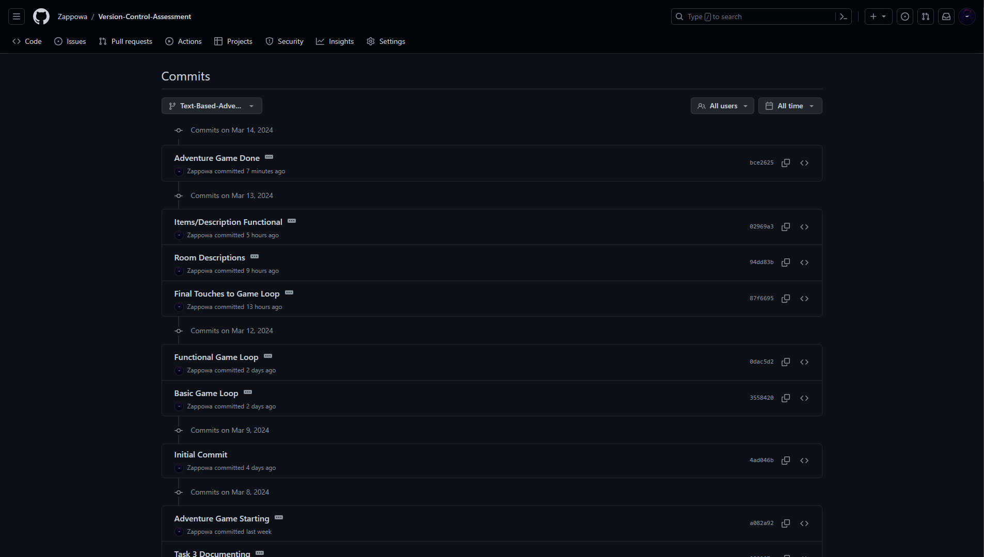

GitHub Branch's

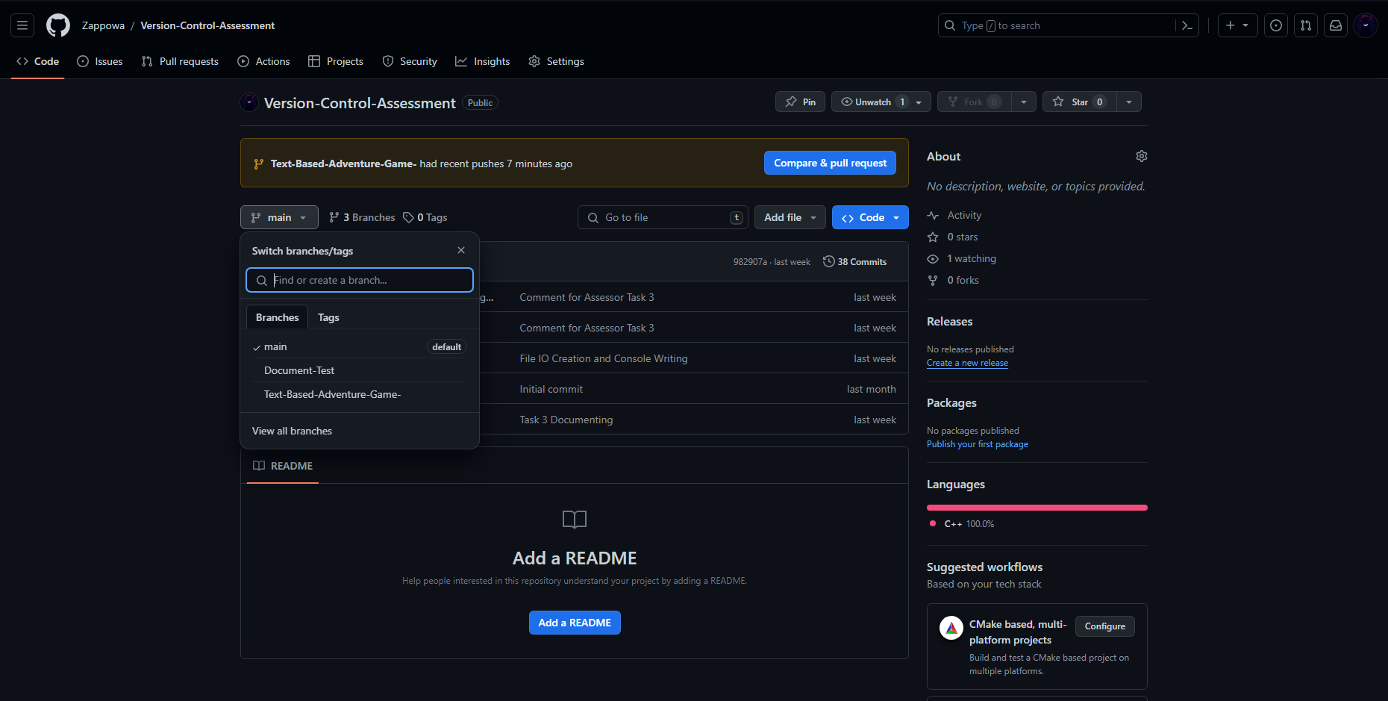

**GitHub Repository (Merging/Pulls)**

// ---- Merge Commit/Pull Request ---- \\

Task 4 Documentation (Branch) -> Task 4 Adventure Game (Branch)

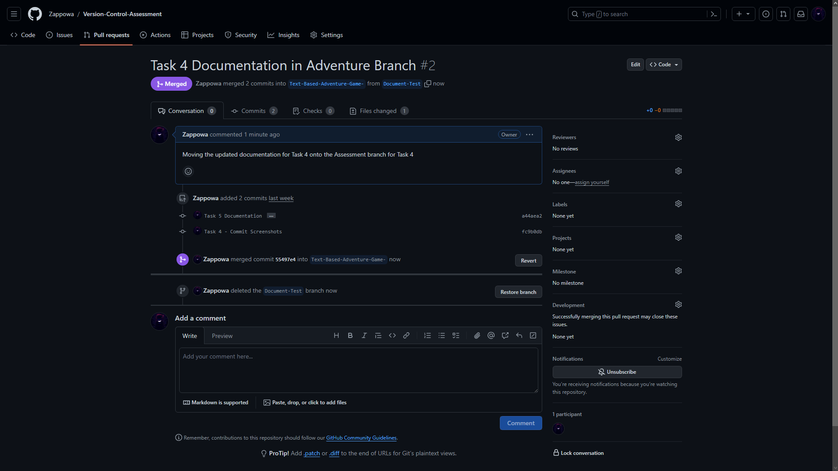

Task 4 Adventure Game (Branch) -> Main (Branch)

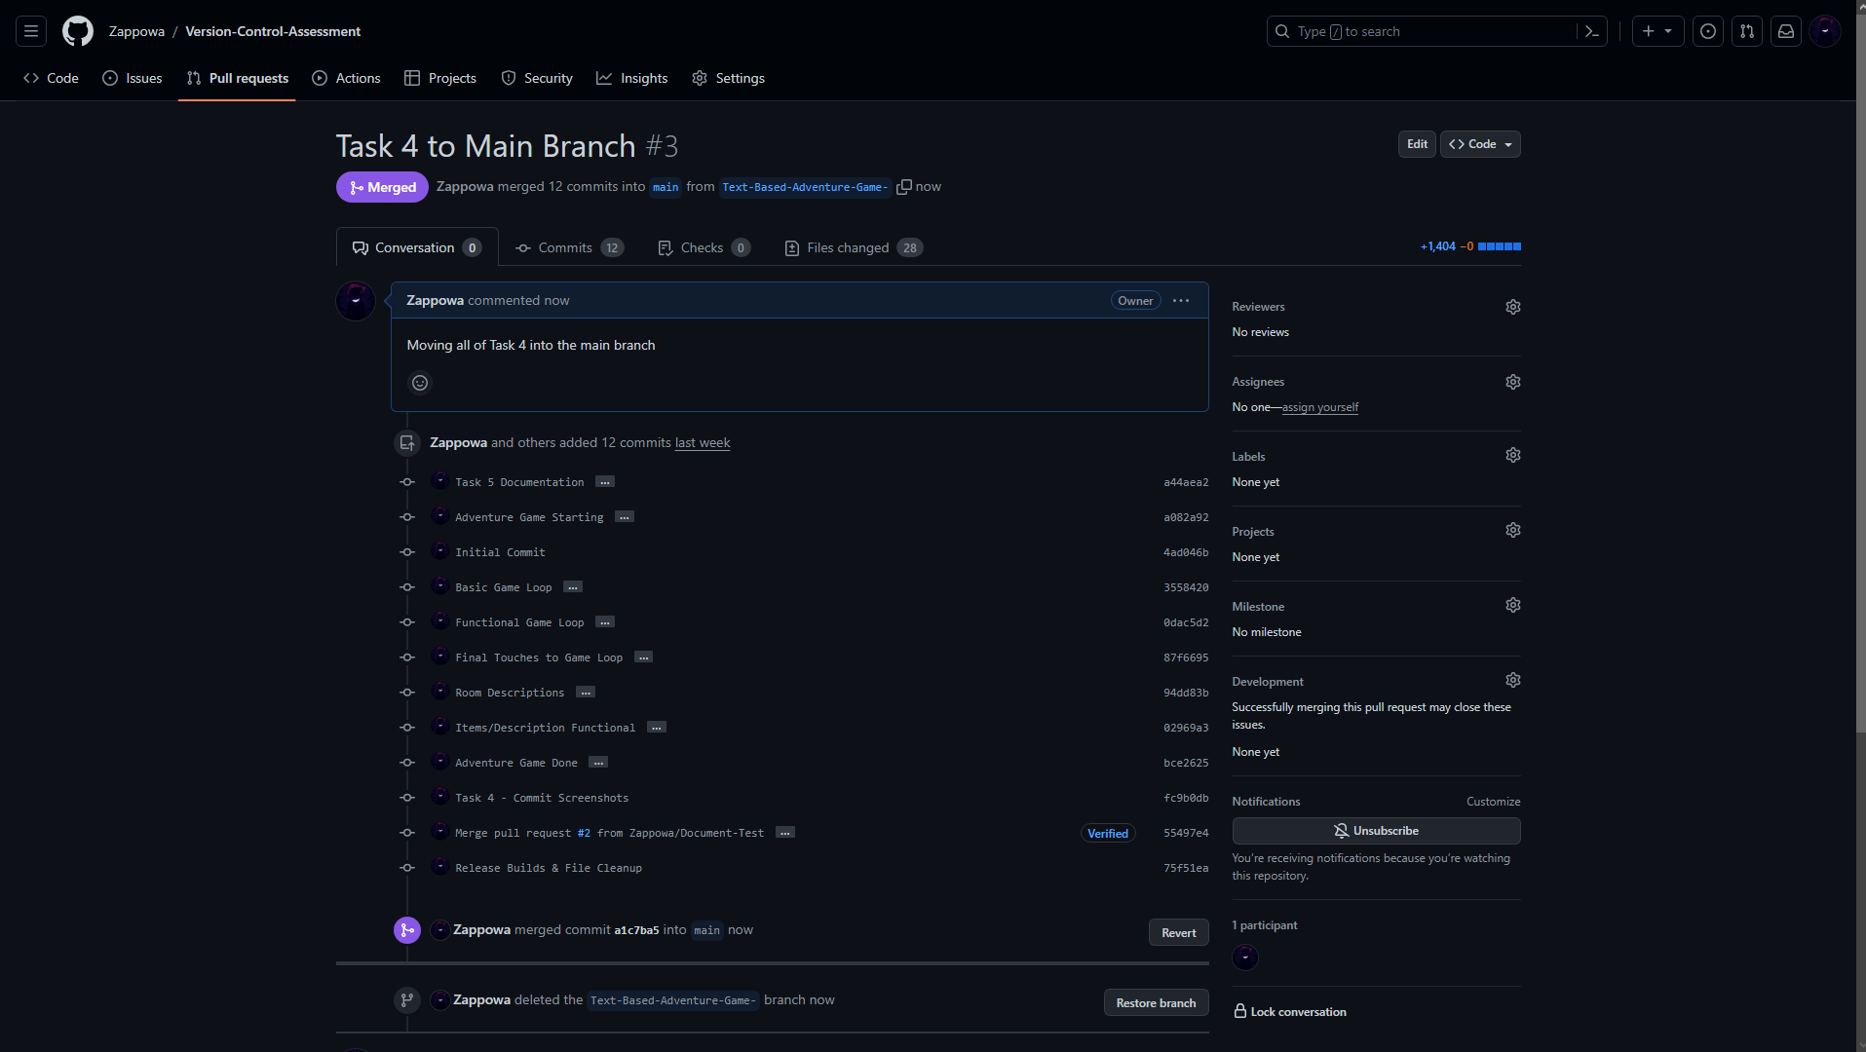

**Challenges**

I’ve ran into a couple minor issues when using version control for this assignment which have all been resolved to date. My first merge commit attempt ran into trouble because of some (not important) files which were conflicting between my main and branch, the attempt to pull resulted in the repository guiding me towards an editor which would clone and merge my data using command functions, I didn’t take this route because I was unfamiliar with it so instead I went onto the GitHub Desktop App to attempt a resolve where I was greeted with the option to choose which files I’d keep and remove. I prioritised my main branch and kept the files in there as I had more progress built onto it and would prefer to protect my main rather than the branch. The other small issues were when I had changes on two different computers with both being 2 behind and ahead in commits, this was solved by stashing my changes in one and fetching the origin from the other. Then pushing my stashed changes which solved the problem.

**Weaknesses**

I’ve used most of the fundamentals with GitHub previously and a couple things I don’t quite have the grasp of yet consist of the “.gitignore” file and how to manage that correctly, the editor when solving conflict through there isn’t as intuitive and harder to learn. As well as general pulling and merging which I haven’t done much off and this assignment would provide light on it for me. I personally believe that organising and placing key information into the commit’s description is important and I did fail to do at times although I managed to get a bunch of descripted commits. This will help in team environments as well as documenting the game/codes progress. A good way to resolve some of these are by practicing using GitHub under various scenarios for example using a different IDE or Engine which might cause different problems and push my comfort zone with unfamiliar environments. Researching online and finding resources to aid me in my learning will benefit me and my future version control abilities.

**Resources**

Most of my GitHub knowledge comes from college where I did game development and had to use GitHub App to do version control with my team, I will be unable to provide many due to this fact.

* The only resources I used were from the AIE Canvas